**2**



COMMON ASSESSMENT TASK

**Level 2 Digital Technologies and  
Hangarau Matihiko 2021**

**91899 Present a summary of developing  
a digital outcome**

Credits: Three

|  |  |  |
| --- | --- | --- |
| **Achievement Criteria** | | |
| **Achievement** | **Achievement with Merit** | **Achievement with Excellence** |
| Present a summary of developing a digital outcome. | Present an in-depth summary of developing a digital outcome. | Present a comprehensive summary of developing a digital outcome. |

Type your School Code and 9-digit National Student Number (NSN) into the header at the top of this page. (If your NSN has 10 digits, omit the leading zero.)

# Answer all parts of the assessment task in this document.

Your answer should be presented in 12pt Arial font, within the expanding text boxes, and may only include information you produce during this examination session.

You should aim to write between **800–1500 words** in total.

**Save your finished work as a PDF file** with the file name used in the header at the top of this page (“SchoolCode-YourNSN-91899.pdf”).

By saving your work at the end of the examination, you are declaring that this work is your own. NZQA may sample your work to ensure that this is the case.

# You may only access the digital outcome and Common Assessment Task. Internet access is not permitted.

© New Zealand Qualifications Authority, 2020. All rights reserved.

No part of this publication may be reproduced by any means without the prior permission of the New Zealand Qualifications Authority

**INSTRUCTIONS**

Read all parts of the assessment task before you begin.

Choose any digital outcome that you developed during the year.

Type your chosen digital outcome in the space below:

|  |
| --- |
| 3D Platform Shooter Game(Made in GODOT engine) |

Begin your answers on page 3.

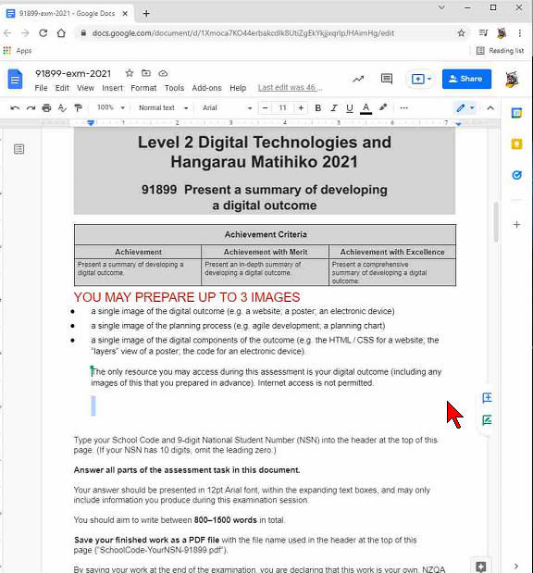

# ASSESSMENT TASK

(a) (i) Describe your chosen digital outcome.

|  |
| --- |
| The digital outcome I chose was a 3D Platform Shooter. Based off of and using similar conventions to that of Swordigo, Golden Axe, and Sword of Xolan, the game was titled Alternite and had a main theme of stages of anxiety and depression, based In a nightmarish realm. For this game, I was the coder. This role included coding the player movement, enemies etc.  To help fit this theme, I tried to go for an action/horror genre, and to slowly develop the story over the duration of the game. To start off with, the player was a variety of casual colours, dreaming in a nightmarish realm. As the player would progress, they would come across a variety of ‘nightmares’, creatures that the dreamer had conjured that would need to be defeated to progress. These included a flying, bee or wasplike enemy, a spider, ground enemy, and an enemy that couldn’t be damaged, but only evaded. These were all based on common nightmares that people have. Slowly, as the game progressed, the colours of the player would slowly change from colours, to dark grey, then to black. This was to represent the downward path of a victim of depression or anxiety. To add to this, there were several bosses named after different emotions or feelings, such as Peace, Greed, Anguish, and Jealousy. When the player was still in the ‘white’ stages, they would battle the negatively themed bosses, kind of like battling their inner demons, and in the ‘dark’ stages, they would battle the positive bosses.    To add to the theme again, the game was a simple dark/light themed game. The background was a plain black background, and the remainder, i.e., platforms and enemies were themed appropriately. The player had an option for two attacks, a projectile and a melee attack. The melee attack would not use up ‘light’, a type of mana implemented for our game, whereas the projectile attack would. Overall, there were 7 different levels, each with varying enemies, pickups, bosses, and levels of difficulty. Obviously as the game went on, the levels became harder and harder, to symbolize the increased difficulty faced by depression patients for the longer they go without help. If the player reaches the end, they meet a otherworldly figure who rehabilitates them and tells them to wake up, revealing that the player is actually representing the dreamer of the game. |

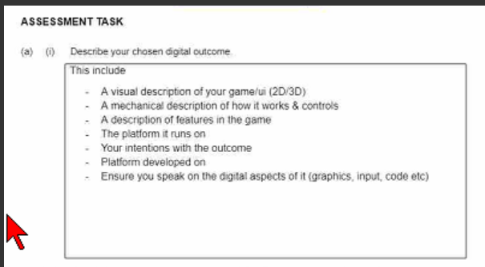

(ii) Explain the reasons for some of the decisions that you made during the development process for your chosen digital outcome, with regards to:

* + the sequencing of key tasks in the development of the digital components
  + the selected methods chosen to address requirements.

|  |
| --- |
| The major decision made at the start of the development process was to start with the characters and enemies. I made this decision because I knew that these would be the most time-consuming, and if I spent too long on building levels or menus, I would put pressure on myself to finish them later. The player especially took a long time, I spent a while trying to figure out how to implement a double jump into my game. This ended up clashing with other required code and I had to scrap it. Once the enemies, player, and bosses were complete, the level building would not take long as I already had all the resources required, and there was not as much pressure to create high quality levels.  I also made a decision to alter controls for my game. Instead of having the typical WASD and SPACE control mapping, I changed it instead to the arrow keys, X, and Z. This was done to make the game seem more like an older game like Mario, using different controls to many other typical platformers. Not only did this make the usage of the arrows more appropriate, but it also allowed for more of a challenge for the players of my game. They would have to get used to the controls in order to become proficient at the game. On the feedback I got, it was suggested that I change the controls back to the typical format, but instead I added a ‘Controls’ menu so that the players could learn the controls a bit easier.  When I was designing my game, I set myself a few different requirements for my game, as well as a minimum product I would like to produce. To help implement these requirements, I used the ‘cycle’ system. Using Trello.com, at the start of a three week period, I would identify in a section what I would like to implement, decide, or create. I would then spend three weeks completing the task, and then I would present my outcome and gain feedback to help me make more decisions. Then, I would evaluate my progress on Trello, to help me gauge my next goals. |

(b) (i) Identify at least two of the requirements of your chosen digital outcome and discuss how you addressed them.

|  |
| --- |
| The main two requirements I decided on for my game were a fully functional character, and a fully functional title screen.  When designing the main character, we identified that the player would need to be able to jump, run, and attack. After this, I planned the order in which these would be completed and would work on these until the model was finished, starting with the attack. The ‘attack’ category would be split into two parts, a melee attack and a projectile attack. I decided that the melee attack would not use up ‘light’ which was a form of mana implemented to stop the player from constantly attacking, while the projectile attack would use up mana. This was implemented thought he use of a sword and a ‘bullet’ or bolt. The projectile was relatively easy to code and works, shooting whichever way the player is facing at the time, and this was the same with the sword, except there had to be an animation showing the swing. The jump was going to be a large jump, and a double jump. However, the double jump code began to clash with other required code, and therefore I was forced to scrap that idea. The jump, however, works perfectly and the player can jump, but has a limit so that it cannot jump infinitely. The major changes in the plan for the requirement were in the animations. Under a time limit, we were forced to change the animation to a simpler one than we would’ve liked. This was the running animation, and it still works relatively well except for a bit of a weird finish to it.  The other requirement was a fully functional menu or title screen. In the design process, I decided that the menu would contain a ‘New Game’ button, a ‘Controls’ button, an “Options’ button, and a “Quit’ Button. The New Game button simply changed the scene to the first level of the game, putting the player right into the action, although I had to be careful not to make the level too hard, as there was little warning that the game would start right away. The Controls button took the player to a different menu with the controls of the game. This was necessary due to the different controls of the game that the player would need to get used to. It contained the controls for all of the player’s abilities, as well as hinting at a ‘secret button’ hidden in the main screen, as a small easter egg. The Option button took the user to another screen, this time allowing them to change the volume, and to toggle the sound or music on and off. The main menu also had intense music gained from Endemic Sound, which added to the suspense of the game. |

(ii) Discuss how your chosen digital outcome addressed TWO of the following relevant implications:

* functionality
* usability
* aesthetics

|  |
| --- |
| **Functionality:**  Our game had to be functional. This meant bug-checking, fixing, and getting feedback, all of which was crucial to the functionality of our game. It also meant having a fully functional player and enemies, to make the game playable. To address this implication, we implemented the cycle system mentioned earlier. This process helped me to bug-check and get feedback on code and level setup especially and helped to point out things I had missed so that I could fix them up. For our game to be fully functional and ready for the end-user, we needed to have varieties of different models, like platforms, bosses, the player, enemies etc.  I also had to play my game a lot. This was essential as I needed to play through a level and take notes on what works and what doesn’t, whether the level layout is impossible to play, or the enemy is bugging out, or the projectiles aren’t firing. Playing the game helped me to gauge how much work I would have to make the game function and allowed me to be more efficient. Efficiency was key for the functionality of my game, especially when coding different aspects. I had to be quick yet thorough, so that my code does what it’s supposed to, and I still have time to check for bugs and fix it up. One of the major bugs I faced was that the projectile was passing through the enemy and platforms instead of colliding and disappearing. To fix this I had to add a group to the bullet telling it to disappear when colliding with another object.  **Aesthetics:**  The aesthetics of my game were important to the theme. To me, the theme of anxiety and depression, or social issues, would mean a dark theme to fit the brief. My game addressed this by using a simple black theme, with some lighter bits. For example, the platforms of the game were black with white outlines, and the player model slowly changed to black. As mentioned before, this was to represent the path that victims of depression or anxiety may follow, so a bright, happy theme wouldn’t work with my game. The location of the game also fits the theme of the game, located in a nightmarish realm. These colour choices were confirmed by the setting I had chosen. A nightmarish realm would not be a happy place, instead barren, deserted, and scary. This is also why the enemies were based off common nightmares that people have. Finally, the music chosen was important for the implication of aesthetics. I chose a music track under the ‘Horror’ section of Endemic Sound, mainly to add to the theme of horror and darkness.    **Dark themed level(1)** |

(c) You followed a development process to achieve your chosen digital outcome.

(i) Evaluate the decisions you made in the development process for your chosen digital outcome.

|  |
| --- |
| The decisions made around sequencing were the best decisions I made. Not only did it allow me to have greater focus on a more important aspect of the game, but it also speeded up the time it took to get the major requirements done. I started to get more and more into the work as the game went on, meaning I became more and more efficient at different tasks. Making the player and enemies first left me lots of time for the menu building, level building, and bug testing for the game. This also meant that the player, enemies, and levels especially were of a higher quality to provide a better experience for the end user rather than just another budget game. I changed the controls for the game in order to provide a challenge for the end-user and provide a challenge it did. Even for me, the implementer of the controls, this proved a challenge. There were countless times where even I forgot the controls to my game, and this prompted me to create the controls menu to teach the end-user the controls.  I also haven’t regretted the decisions made on the aesthetics of the game. I think they clearly reflect the theme we decided on and the purpose can be easily uncovered. The nightmarish realm was a perfect fit for the theme of our game, as for many victims they see their life as a bad dream. This also allowed for the theme of horror and darkness to become apparent. Most of the decisions I made were relevant to the task I was working on currently, and only positively benefitted the game. |

(ii) Discuss what you could have done differently for the digital components to improve your chosen digital outcome.

|  |
| --- |
| I think that a major difference I could’ve made was my own personal efficiency. While I had a pretty good efficiency, I often got trapped on different parts of the game, trying to fix it over and over, to no avail. I think if I had set aside some of these things, I could’ve gotten a bit more done. A major example of this during the development process was my double jump. The original plan was for the player to be able to double jump, as well as just doing a regular jump. However, this fell through as I became stuck on this for so long that I decided to scrap it. Unfortunately, this meant that I had limited time to work on the user interface of the game and meant I didn’t finish it to as good of a standard as I would’ve liked. The time wasted on the double jump impacted other parts of the game negatively and removal of the wastage would have allowed for extra time.  Secondly, my compatriot and I should have collaborated more on the task. Our two roles became increasingly more separate throughout the development process and this ended in us having very different ideas on what the model should look like, and time wastage on re-modelling after finally collaborating on the models. I also should have let him have more access to the game in GODOT, so he could see where I was at and where he could work on to make my job and his job easier. On the same branch, I don’t think I would work in a group next time. By myself, I completed far more work than the modeler, and there were countless times where I was at a roadblock waiting for models to progress, having instead to work on the very limited number of bugs in our game. It started to feel like more of an individual project, as one time I had to create a model myself as the previous one was so poor. I reckon if I had chosen to work individually, the outcome could have been much more than it is now, and I would be much more satisfied with it. |